
Role with responsibility for implementation and review

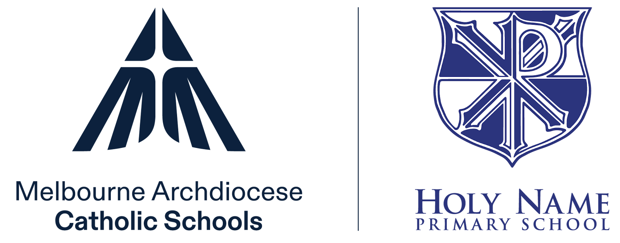

Curriculum, Assessment and Reporting Overview for Parents and Carers

- Curriculum provision
The learning and teaching program at our school is designed to deliver a common set of knowledge and skills, to give every student the opportunity to experience the full scope of the curriculum.
Requirements of schools | Schools are supported by

Curriculum
F–10  - Implement the Victorian Curriculum (or other accredited and approved curriculum framework) in learning programs and for assessment and reporting purposes.  - Develop a curriculum plan showing how the Victorian Curriculum learning areas (or other accredited and approved curriculum framework) and religious education curriculum will be substantially addressed, organised and implemented (this may occur across a two-year cycle to ensure coverage of the achievement standards and to meet the needs of students).  - Explain how and when curriculum and teaching practice is reviewed  - whole of school  - year level  - class  11–12 (where senior secondary programs are offered)  - Implement the relevant accredited curriculum framework for which the school is registered and approved. | - Victorian Curriculum F–10 (or other accredited and approved curriculum framework)  - Religious Education curriculum for the Archdiocese of Melbourne  - Vision for Instruction  - Vision for Engagement  - VCAA VCE and VCE VM study designs  - VCAA VPC curriculum designs  - IB study designs

Adjustments to learning
- Use a whole school approach to implement adjustments to teaching and learning for all students including:  - students with diverse learning needs  - gifted and talented students  - students with imputed needs  - students with English as an additional language or dialect (EAL/ D) | - Victorian Curriculum F–10 including Foundation levels A to D, EAL  - Vision for Instruction  - Vision for Engagement

Student learning
- Have appropriate processes to support students to progress towards and achieve the learning outcomes expected for their student cohort (either age-related or curriculum related as per key learning area specification).  - Plan and achieve improvement in student learning outcomes, including:  - evidence of standardised assessment schedules for all students, including comprehensive assessment schedules to identify students at risk  - evidence of using and reporting on national testing data (i.e. NAPLAN, VCE, VCE VM, VPC and VET data), international testing data (TIMSS and PISA) as required, and On Track data as relevant  - data collection schedule, with explanation of how the data is analysed, stored, and student self-reflection reports and action plans  - evidence of using student learning outcomes data to inform goal setting against the relevant accredited curriculum framework and to design improvement strategies  - how the school analyses and uses data to set goals and targets for outcomes, and to design improvement strategies, including for students at risk  - teacher professional learning that is informed by an analysis of student performance data (for example, a plan to improve student learning outcomes including what data the school collects to monitor outcomes)  - personalised learning plans, appropriate interventions or adjustments, and support groups to assist students who require additional support. | - School improvement survey data  - School data snapshots  - Victorian Curriculum and Assessment Authority (VCAA) data service  - School Improvement Framework (SIF)  - School Improvement Plan (SIP)  - Annual Action Plan (AAP)  - Victorian Curriculum F–10 (or other accredited and approved curriculum framework)  - VCAA VCE Administrative Handbook and/ or the VCAA VPC Administrative Handbook or the IB Handbook as relevant  - VCE and/ or VCE VM Study Designs and/ or VPC Curriculum Designs or IB Curriculum Designs (as relevant)  - Teacher professional learning (PL)  - In-school PL  - PL offered and/ or sponsored by MACS  - PL delivered by the VCAA  - PL offered by external parties
- Assessment
The assessment approaches are designed and mapped against the relevant accredited curriculum framework. This is to ensure that assessments are linked to, and accurately measure, student knowledge, understanding and skills as outlined in the relevant learning areas, study designs or curriculum designs.
Teachers are required to assess and monitor student growth, learning progress and achievement against the achievement standards in the curriculum framework and within the learning and teaching program.

Expectations of schools | Schools are supported by

Assessment
- Assessment and recording practices play an important role in the development of the learning culture within a MACS school.  - Assessment is a means for leaders, teachers and students to engage with parents to identify student learning progress and opportunities for further growth and development.  - Across every MACS school, there is a goal for equity and excellence across the spiritual, physical, cognitive, social and emotional domains for each student.  - This multi-dimensional approach to assessment of learning respects the sacred dignity of the learner and engenders a sense of being valued and understood. | - Victorian Curriculum F–10 (or other accredited and approved curriculum framework)  - VCE and/ or VCE VM Study Designs and/ or VPC Curriculum Designs or IB Curriculum Designs (as relevant)  - Standardised testing including NAPLAN  - School-based testing
- Monitoring and reporting on student performance
Requirements of schools | Schools are supported by
Schools
- Have evidence in the form of the school’s policies and procedures for assessing and monitoring student progress and achievement, and how this is reported to parents.  - Undertake ongoing assessment, monitoring and recording of all student performance to report on progress and achievement, in the form of a written report, to parents at least twice a year.  - Report on student achievement against the relevant standards as outlined in the Victorian Curriculum F–10 (or other accredited and approved curriculum framework).  - Provide parents with opportunities to discuss their child’s progress with the school. | - Reporting Student Progress and Achievement: Guidelines for Victorian Catholic Schools (VCEA)

School review of assessment and reporting practices
- Have policies and procedures in place to:  - maintain accurate student records  - ensure the integrity of student assessments  - monitor student participation, completion rates and student outcomes.  The policies and procedures must cover the analysis of results and student participation. | - System Improvement Survey data  - School Improvement Framework (SIF) Rubric  - School data snapshots

- School performance
Requirements of Schools | Schools are supported by

Schools
- Monitor and report to the school community on its performance at least once per year.  The information must include:  - A description and analysis of student learning outcomes achieved by the school’s students in statewide tests and examinations in which the school participates for:  - the current year; and  - if the school has been established for more than two years, the previous two years.  - A description and analysis of rates of student attendance for the year. | - School Improvement Survey data  - School Improvement Framework (SIF) Rubric  - School data snapshots

Approval authority | Director, Education Excellence
Approval date | 11 November 2025
Review by | November 2029
Publication details | CEVN, internal school use
School document owner | Principal
School reviewed on | 4/12/2025

